2019
Gerty-Anne Delpeche

Word count 1028

[A horse with no name]
Allow me to provide some background about the topic of naming ponies A: Shirley had the” Just” prefix that was reserved for the crème Della crème a hose does not become for instance a Just Must Have overnight and B:Her Jack Russell’s were named after her favorite sandwich Cheese, Tomato and Onion.

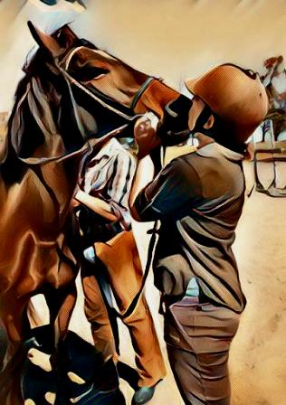

It was usual to find a random pony, horse, or both on Tuesday mornings as I entered the yard. Some came with credentials; others were more Jane and John Doe. Shirley had been expecting a Friesian cross; I assumed the new one in the paddock must be it, however, it really could have been any pony as they were moving fast through there. The madam was running around that morning there was no clear instruction as to what I must do with the new pony, nevertheless, it was not brain surgery. I had a hunch; I would have to ride him, therefore, I would make time in order to do so. In spite of my best-laid plans, I got rather busy that morning and ran out of time. A result, I got to thinking perhaps I could get everything done by riding the pony in the big lesson after lunch. Two jobs in one big country lesson The madam would be proud this was what she taught me to things the way she how she would have done it therefore what could possibly go wrong?
For one thing, one hundred young riders showed up thus the lesson was now much bigger than planned. In addition, the lead horse has to do exactly that and lead should he choose not, it could end very badly indeed. What to do in a situation like that is the following tack up, get on and go in that order. You have heard the expression idle hands well; there is such a thing as idle hooves. For that reason, kids were placed on ponies real fast meanwhile I did a head count and a quick check that everyone’s everything was correctly fitted and fastened. I was moving fast by then and not wanting to break my stride, I simply mounted on the brick driveway and trotted out in front of the other ponies whilst bellowing to my riders to follow on. Halfway down to the paddock I thought “Okay so far so good.”
It had been raining and so the dam was full. Right off the bat, we had to jump two novice ditches in order to gain access to the cross-country that is a hell of a warm-up nevertheless there was no turning back. Off “new pony” and I went with a string of ponies following us. I looked up and kicked; he jumped and put in a huge buck in on landing and again over the next ditch, I smiled. If it bucks it jumps, I could sit a buck it felt familiar. In fact, I felt all tingly and promptly cantered off to start the lesson. As we went around the country, we jumped and bucked along the way yet with all the kids still on their ponies, so afore away! We were going well forward by now and this was okay, as we were in the country forward is the way. At the same time a thought ran through my head, ‘”He is quite something this “new pony” being his first time out. I felt I should, I ask him some questions, just to see what he would say. About a few bigger rustics, a bank and the corner jump, however, I will approach on an angle so that it is not too easy or inviting. Hence, no matter what happens when Shirley asked questions, and she would, this way I would have something worthwhile to say. He jumped everything, even though I angled the fences as well as the up and downs. The banks did not present a problem yet he bucked, big and all the while. We jumped the wall and combination on our way back to the yard; we were pleased as pie that lesson went so well.
Not bad for an afternoon riding as the kids got educated and I sat on a gem. I jumped off “new pony” scanning the yard but alas the madam was yet to return subsequently I told Jack “New Pony” did well” Jack's eyes opened a bit bigger now, although I thought nothing of this he often looked at me as if I was insane. As such, I took no notice and headed for the trees where there would be a glass of tea for me, I earned it or so I believed. A few clients gathered to hear about the ride and it appeared they were now staying for tea too Just about then, the madam pulled up the driveway.
I went to greet her almost jogging there I was bursting to tell her about “new pony” he was a good one for sure. Shirley got out the Pajero with a bottle of Montez as if she knew, she probably did know already she always knew, she could pick special by magic this much is true nonetheless for me it was all and exciting. Accordingly, I rambled off the highlights, the big jumps the big buck I believe I said: “Shirley he is fearless it was awesome, you’re going to love him.” She was silent walking to the tea garden and on arrival promptly sent me to fetch appropriate glassware; we drank Montez with a touch of class. On my return, Shirley as a matter fact asked, “Ginni you do realize that the “new pony” isn’t broken in, he has never been under saddle.” I could feel the blood drain from my head and took a quiet moment for contemplating as I recounted all the very many ways things could have gone wrong. On the other hand, it did not hence, my reply was simply “Well, Shirley he is now.” Shirley named “new pony” you guessed it Montez and he would become a bigger part of my life than I could possibly have imagined

