Valliant
Words count 2386
A true story
Gerty-Anne Delpeche
7/1/2018

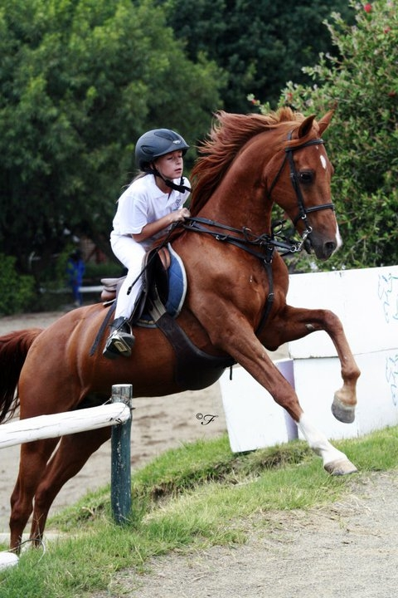

By the time, our paths did cross Valiant was already a champion show jumper, competing in the children's higher grade classes. Denton Sander produced the pony and rider however in those days, I was blissfully unaware of Denny; actually, I was still coming to grips with working for Shirley Green, which in itself was fraught with difficulties. I had no clue as to the force of nature that was about to be unleashed upon the yard. Denton just materialized, as if by magic at Mean Greenies stables, I can recall the precise moment, the winds came up and simultaneously and as if on cue, the hounds at Inanda Country base went bonkers, they knew he had arrived! Later I asked Shirley how she conjured it up, she chalked it up to excellent timing or mere luck. Well, either way, it was fitting of a pivotal life-altering day.
The young chap who rode Valliant at the time was nearing the end of his pony rider career. Their grand finale would be at SA pony championships it is a decent way to bid farewell to the children's classes. The sale would subsequently be brokered threw Shirley Green, naturally what with her connection to Denny and being a stone's throw from the show venue. I should mention that sometime in the distant past, long before I was in the picture, Shirley knew the importance of, location, location, location. As a result, she had secured, prime property in the heart of horse country and by the time I arrived on the scene, it appeared as though the yard had simply always been there the same way that Stone Hinge has always been there. So too is Mean Greenies etched into the landscape the view consists of cross-country jumps and up on the hillside, there would be Shirley’s herd of somewhat wild ponies.
Subsequently, for a time I perceived myself to be a land earl, I bought ground all across that cross-country paddock you could say I crisscrossed the country schooling those somewhat wild ponies. However, Valley walked out the box with no assembly required, he was the show ready schoolmaster pony deluxe addition, as a result I didn't pay much attention to Valliant until he officially went up for sale. As expected, everything was running smoothly as things do when dealing with a schoolmaster deluxe edition pony; Valliant did not put a foot wrong; he was perfect, right up to the vetting, of course, he failed the flexion test spectacularly. As a dealer one could assume there would more than likely be some x-rays taken; it was standard for big money horse deals. Most competitive horses would show some wear and tear and may flex somewhat touchy as a result. On the other hand, ordinarily, most horses tend to injure themselves while standing alone in a little paddock mere days before an enormous show or an important vetting it is Murphy's Law. What I learned from Valliant was the following; being sound does not necessarily mean that flexing sound is a given. Straight off the bat, I could see there was trouble afoot, he did not flex sound on any of his legs. When I inquired about x-rays the vet explained it would be extremely costly, as you would need to start from his head right down to his feet.” It seemed he considered this for a moment before he by the wayside added, "I can't remember ever flexing a horse that was lame on all fours, definitely not one still jumping and winning to boot." Impressive he called it. However, it was clear sooner rather than later, there would be problems and it would all be downhill from there. I found myself feeling befuddled as to what happened the bloody pony was sound and had been since day one. That is Murthy for you, and of course, after his massive fail on flexion, not a single vet in Gauteng would go near that sale. It did not seem relevant to anyone bar Shirley and me that the pony had not actually been lame one day the entire time at Mean Greenies. Dropping the price did not seem to help persuade clients that the pony still had mileage left in him hence it presented us with a predicament, well me more than Shirley she had some kind of blind faith or the ability to see the future it seemed me at the time, now I know it was both.
There was still value in Valliant; I knew this to be true, therefore, all I required was the right client with a particular set of circumstances. The kind of client that was in need of the exact skills a schoolmaster brings to the arena. In addition, it ought to be someone that trusted me enough to take my word on the pony’s value and soundness, no questions asked. That was a tall order; I recall my grandfather's advice to my mother was “Never trust a horse dealer.” Ironic I know. Still pondering how to prove my grandfather wrong and in the process conjuring up a trusting client with particular circumstances and special needs, when the Wybenga's ford rolled down the driveway; I waved and smiled as they went past all the while wondering why I did not see it sooner. It just so happened that I sold the Wybenga's a number of amazing ponies hence they had all of the above-mentioned requirements, plus the added advantage that now I would be teaching the girls on a schoolmaster which made my job as an instructor a great deal easier. It did not take too much convincing I simply told Stefan the truth which was “Stefan if you only gain 6-month use from this pony he will still be worth more and do more for the girls riding than the price you paid for him." Stefan believed me and as a consequence Valliant, the pony that no vet would pass had a long career jumping up the grades with all three Wybenga girls. He carried the youngest Cheriese around the show ring for a number of years while the kid grew quite literally into him as though he was a pair of her older sister's boots. She was a tiny, little rider and frankly, I do not recall her being quite so petite. She did eventually grow to be nice and tall, this would be about when our paths crossed again; I would be witness to Valliant’s grand finale, after all, he was my pony so to speak and those were my kids, they still are. I thought it to be serendipitous, I was there when the journey began and now again so many years later at the end.
I am obligated to mention that keeping a special needs pony sound in order to compete at the top level, is no easy feat. Under normal circumstances, I would advise against buying any a horse that failed the vetting however in some cases it can work out to everyone’s advantage though such cases are rare. Also, take into account that Stefan spared no expense in Valiant’s upkeep. He was on the best supplements and his work regimented set up with their trainer and in conjunction with their vet. It was a costly affair, by anyone's standards. It is doubtful whether Valliant’s career would have been so successful towards the end if he had gone to a different home. Evidently, the most profound skill Shirley taught me was how to put the right kid, on the right pony; in this particular case, it just so happened to be, the right three kids.
As the show date grew ever closer, I was eager to see my old friends once again the girls would now be young ladies and the ponies would still be ponies just older and jumping higher. Valliant looked edgy coming out the box something was amiss. I realized while I watch him walk to the paddock we were in deep trouble as he was quite lame. Remember what I said about Murphy's Law before a show, well this time the Wybenga’s had been clever to arrived a bit early therefore Valliant had a few days to rest. Nevertheless, he only had days to recover not weeks and he would need to heal without any drugs or even Ice Man. After checking the contraband substance list, I concluded that we could use actual ice not Arnica, man or tight only ice and support bandages, we required nothing short of a miracle; this was cause for concern, even so, I would attempt to magic the pony sound what else was there to do, except use magic and pray for a miracle.
The couple of "Holly" days before the show became a desperate race to patch Valliant up using only legal substances so effectively nada, zilch, zero, zip, and ice. My grandmother taught me to work with what I have; applying that concept to this situation meant we required more ICE! On that premise, Stefan made contact with a trainer at Fairview racecourse who had a hydrotherapy system for use on his racehorse’s horses. Thankfully, there was time for one session literally on route to the show where Valley was to trot out for the vet check; I was not staying around to watch. Instead, I held my breath and walked away, heading towards the bar. The thought of ending it this way was a bitter pill to swallow therefore I would require a drink to swallow it down with as I mentioned the taste would be less than pleasant.

What happened next would reaffirm my belief that ponies are magic. Valliant trotted level well not 100% level but he did not fail altogether. The judges called Cheriese up for a chat, and did something completely out of character; they would not fail Valiant that day; however should she bring him into the arena unsound, the judges would eliminate him on the spot. A rather considerate gesture from the judges and what a testament to a ponies show jumping career when even the judges believed he deserved to finish with honor.
Desperately we continued trying to work a miracle, on that premise, by Wednesday we had the pony re-shod. Twice a day I would trot him out. To my dismay, he would remain visibly lame thus unable to enter the show ring. The show was ending and still there has been no miracle; we were running out of time. Friday afternoon around 5 pm, I summoned Stefan and Ryan Sander, to come to check Valliant one last time we were hardly out the stable door when Ryan said, "stop! Put him away, he isn't sound." That would be the end of that. Valliant would go quietly into retirement and not with a champion's lap of honor, one that he so greatly deserved it was devastating.
I felt I let Cheriese, Stefan, and Valliant down. I hung back and waited until it was just Valley and me. Looking into his eyes I said, "I can't watch it end like this, I cannot come to this show tomorrow with you standing here inside this stable. However cowardly that may be, it is what it is, I will wait for you at home.” With a heavy-handed pat on the neck and an equally heavy heart, I walked off
The instant I opened my eyes on Saturday morning, I realized it was a mistake. The fact that it was the tragic final day of a cheerless show slapped me in the face, knowing there was simply no way Valliant could possibly jump his round was no motivation to brave the day. Therefore, I bluntly refused, like a stubborn mule to set foot out the door. In addition, would venture nowhere near the car. I simply could not face the finality of the situation, it was perhaps not my finest hour bear in mind, this was to be their moment; there would never be another one like it. We started the journey together at Mean Greenies and managed to be together again, at the final in Port Elizabeth.
In other professions, it is customary to receive a gold watch, for years of service this was my gold watch and I felt hijacked by the universe. Somehow, I let both pony and rider down even though I knew, deep down the chance of healing him were slim and none. As well as my own smorgasbord of unresolved issues, I kept trying to comfort Cheriese yet all I could manage to say was "it sucks." I am thinking that perhaps I should write to Hallmark about that gem "IT SUCKS" anyway, I went about my morning as one does when avoiding everyone else eventually my phone rang breaking the silence, it was Stefan on the line "Ginny" he said, "You won't believe it but Valley trotted out sound this morning. They jumped the 1.2m championship class and placed third!" I was having trouble comprehending what Stefan had said; horses do not in simple terms, heal overnight much less without the assistance of pain medication or anti-inflammatory drugs. Yet despite this, Valliant jumped a spectacular round and managed to walk out the gate sound though for the prize, giving Cheriese had to go collect her rosette on her, other ride as Valliant was noticeably lame yet again or rather still seeing, as I firmly believe that Valliant lied. He pretended to be sound in order to jump his last competitive round on the last day of SA pony championship there is no other explanation for what happened.
I mulled this over in my mind Perhaps, he felt exactly as I did, he was simply too phenomenal to retire standing in a stable. Perhaps he did it for the little girl who grew up on his back. Perhaps he decided sometime during the course of Friday evening, that he would teach me to have more faith in the bond between pony and rider. Valliant made a choice and gallantly prevented a young heart from breaking. Moreover, he subsequently restored in me a sense that magic is real and miracles do happen, all be it just in time.

